UNDP
GLOBAL FUND report on the implementation of the hiv grant 2016-2018
ANNUAL REPORT
Year 2019

Dr lucia

Henrik

Contents

List of Acronyms

Executive summary

I KEY FACTS AND FIGURES

- Angola is among the countries in the Southern African region, with the lowest characterized rate of HIV, with an overall prevalence ranging from 2% to 2.35% in adults aged 15-49.
2%-2.35%

- The vulnerabilities of the 10 – 14-year-old girls lie in the fact that at that age, they are very curious, want to explore new experiences and take any risk to have such new experiences. That is also the age when girls are exposed to the Efiko, a ritual of much importance especially in Huila and Cunene. At this age group, girls start their sexual life.
- Young girls with hearing disabilities from a Special Education School in Rangel district of Luanda claim that:
“People forget that we have the same special needs and do not give us the information we required. We have the same rights and we need to have the information so we can take care of ourselves”
- Discrimination due to HIV status is common amongst the sex workers as well as conflict due to competition for clients
- Working with PLHIV who give their testimony and counselling to others is indispensable.
- S4H- Solar energy constitutes the larger and more evenly distributed renewable resource of the country with an annual average of 1.350 and 2.070 kWh/m2 yearly global horizontal radiation.
- Below 40% of the national population currently have access to electricity; with 70% being in the city of Luanda. Health and education infrastructures outside of Provincial Capitals still have limited access to energy services.
- With a mother-to-child HIV transmission rate estimated at 26% (INLS, 2017), PMTCT is a national priority to ensure a generation without HIV / AIDS.
- The vast majority of men and women aged 15-49 have heard of HIV/AIDS (82% of women and 92% of men), but only 32% of women and 35% of men have a comprehensive knowledge of HIV and AIDS. Comprehensive knowledge of people aged 15-24 of both sexes is equally low (one in three people).

II FINANCE
Just the top level information- ready next week

(note to self) For structure FHI360, LINKAGES – how they use pictures, etc MSH, psi

III HIV PREVENTION

- HIV prevention with adolescent girls and young woman

Project description
The HIV/Aids prevention programme overlooked by UNFPA and funded by the Global Fund focused on out-of school adolescent girls and young woman between the age of 10-24 in the provinces of Luanda, Benguela, Huila and Cunene, with the duration of two years starting on September 2016 to June 2018.

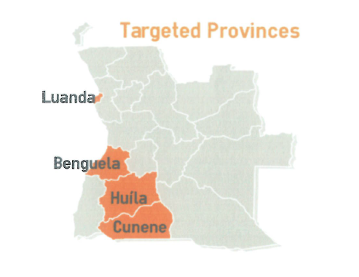
Source- does it need?

Interviewees of the “Independent evaluation of UNFPA HIV Prevention Project with AGYW” (June- July 2018) identified the most vulnerable age groups being 10 – 14 years old and 15 – 19 years old. According to them, the vulnerabilities of the 10 – 14-year-old girls lie in the fact that at that age, they are very curious and want to explore new experiences. Thus, taking any risk to have such new experiences. That is also the age when girls are exposed to the Efiko, a ritual of much importance especially in Huila and Cunene. At this age group, girls start their sexual life.
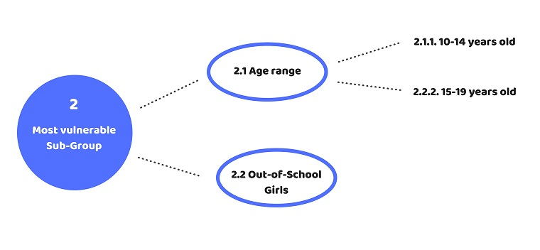
source
The target of the programme was to strengthen Angola’s national response to HIV/AIDS by reaching 30,000 beneficiaries with HIV with quality information on prevention, and test 10,000 of the targeted girls for HIV infection by June 2018.
The strategy defined was the implementation of “Bancadas Femeninas” (BF), which provided the beneficiaries with a welcoming space where they could discuss their experiences and concerns related to the sexual reproductive health and learn about their rights. These BF worked by having an animating activist each, who is trained and experienced in ASRH and HIV/AIDS. This individual would bring together a targeted 150 girls together that would engage with the project until its finalisation in June 2018. Each BF was targeted to hold 6 discussion sessions per month for around 90 minutes each, with an average of 25 girls per session.
Development Aid from People to People (ADPP), Youth Support Center (CAJ) and Association of HIV/Aids- positive and activist against HIV (Aspalsida), were the implementation partners contributing to the social mobilisation of the beneficiaries. The visits by the UNFPA Regional Director helped to kick start the needed reinforcement of the coordination mechanisms for the prevention of HIV among youths, especially young girls. In addition, strategic meetings with the Vice-President, Ministries of Health and social Affairs, Family and Woman Promotion were conducted with the key messages endorsing the joint programming to promote adolescent health.

Results
Initially from June to December 2016 the intervention reached 3,766 adolescents and young people of both sexes between the age group of 9-25. However the resulted and presented information focused on the purposes of the programme; out-of school adolescent girls and young woman between the age of 10-24. The end results exceeded the 30,000 targeted beneficiaries by 12%, with 33,672 girls reached.
In the Province of Luanda, in addition to the BF, UNFPA availed of the Adolescent’s Fair strategy in partnership with the Ministry of Youth and Sport/ Informed, organised and Responsible Youth Project (JIRO). Apart from the dissemination of qualified information, the fair was also an advantage as it offered the provision of sexual and reproductive health services, including voluntary counselling and testing for HIV. The fair’s animation with artistic performances by musicians, theatre groups and human statues helped spread the HIV/AIDS and STI prevention messages and make this social mobilisation a success.
The aim was to reach 7,500 girls by province, yet Huila, Benguela and Cunene had surpassing results of 9,807, 9,257 and 7,518. Luanda had the lowest number of girls mobilised with a total of 7,090. This was due to the difficulty in obtaining safe areas for the BF and the most experienced and well prepared activists convened by the consultant were involved in preparatory courses for entry to the university, thus being unable to bring together beneficiaries. Although Luanda had a lower volume of girls, 95% of the target was still reached. In addition, the project was able to successfully reach 60 young girls with hearing disabilities from a Special Education School in Rangel district of Luanda.
“People forget that we have the same special needs and do not give us the information we required. We have the same rights and we need to have the information so we can take care of ourselves”
(Isabel Beth, 20-year-old girl living with hearing disability/UNFPA)

One result that links to innovation and good practice was the launching of the Oi-meninas application with the support of the Ministry of Youth and Sports (MINJUD) and the Ministry of Health (MINSA) as well as the incorporation of this initiative in the nationwide programme JIRO (Juventude Informada responsavel e Organizada). The app is a quiz game about sexual reproductive health, with progressive levels of difficulty, composed by blocks of questions appropriate to the different age groups.
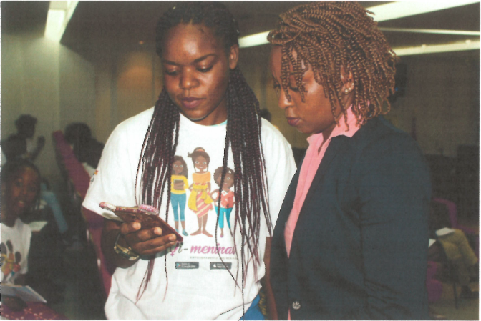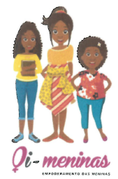
source
The HIV counselling and testing results were below target with a number of 7,885 total HIV counselling and testing performed during the project in the targeted provinces. This represents 79% of the total 10,000 targeted prevention measure volume. Cunene covered majority of numbers with 2771 tests and counselling, followed by Luanda with 2496, Huila 1849 and finally Benguela with 769. Most of HIV positives were in Huila with 29 results, Cunene had 17, Luanda 3 and Benguela 2. UNFPA assisted implementing partners with appropriate counselling interventions for the different age groups, provided guidance on latest strategies applied to reach adolescents and young people and ensured alignment with the national efforts and programmes linked to promotion of rights, elimination of stigma, discrimination and reference to the health services. A message to maintain a healthy lifestyle including responsible sexual attitudes and behaviour was also spread to those adolescents and youth people found HIV negative.
Human impact
Paulina is a local activist from Huila living with HIV for 18 years, she found out she was HIV positive when her son aged one fell ill and died by AIDS. After this sad episode, she decided to advocate for HIV prevention and promote quality care for people living with HIV. Paulina and other people living with HIV (PLWHIV) founded a CSO, called Aspalsida, in Huila. This Civil Society Organisation (CSO) is widely known at provincial and national levels and Paulina testimonies have proved to give hope and gain confidence for people to take the HIV test and live with HIV with dignity and respect. She has been supported by her husband who is HIV negative until now. the couple have three children, all of them HIV free.

Challenges
- Legal requirement for parental permission
- Boys and young men also have limited information on HIV prevention, SSR and other related issues.
- The HIV counselling and testing experienced lack of tests available at the referral units throughout the project timeline.
- Stock out of tests from INLS was major challenge for some periods of the project (January to March 2018) which affected the expected results for HIV diagnose test among young girls aged 10-24 years old.
- Decreased pace of field activity due to school vacation period.
- Launching the application oi-meninas in a short time and with engagement of Ministries of Youth and Sports and Health was a great challenge.

Lessons learned
- The boys are also in need of targeting.
- Initially, in relation to the adolescent’s fair, only five girls from 10-14 years old attended the event, which reflected a possible limitation that girls, especially younger ones faced in order to participate in such type of activities. However, contrary to common belief, there was no resistance from the beneficiaries’ side to proceed with HIV testing and they were also encouraged by family members to take the test, regardless on the need for the parental/guardian consent.
- The IPs supervision needs to be reinforced to support them in terms of capacity building.
- The 2018 UNJTA work plan, funded by UBRAF, will play an essential role to reinforce the INLS technical capacity to the new infections prevention among adolescents and youth initiatives.

- HIV prevention with female sex workers

Project description (time frame of the project missing)
Management Sciences of Health (MSH) carried a HIV prevention with female sex workers (FSW) project with Luanda as the geographical focus. FSW in Angola are quite diverse:
  - Overall literacy level is low.
- The vast majority have family responsibilities. Balancing between their work as a sex worker and family responsibilities is a daily struggle. Many bring their children to the meetings.
- Their income is crucial for the household’s subsistence. The majority come from a limited resource background.
- The majority haven´t disclosed their occupation to their families. Embarrassment and self-stigma play a role. Some continue to deny their identity as sex workers.
- Discrimination due to HIV status is common amongst the sex workers as well as conflict due to competition for clients.
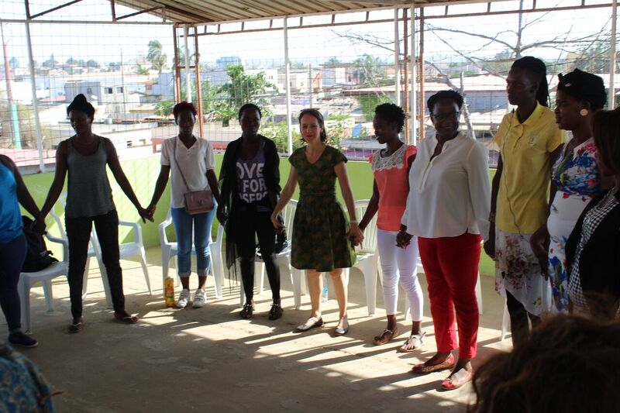
source. FSW
MSH looked to reach its target by providing psychological and clinical support to victims of gender based violence (GBV), creating drop in centres (DIC) for key populations (KPs), and implementing sex worker empowerment approaches as part of the program strategy with rights education and organizational support for sustainability. 35 peer educators, HIV counsellors, and peer navigators (people living with HIV) from ASCAM and MWENHO organizations were trained on the following topics:
- Correlation between Key Populations (KP), HIV, and violence;
- The importance of addressing violence within HIV prevention programs;
- Gender norms and core concepts;
- Gender Based Violence (GBV) concept and types;
- GBV screening and documenting cases;
- Barriers to disclose violence and how to overcome them;
- Consent and confidentiality;
- First line of support;
- Personal experiences of violence; and
- Self-care.

The curriculum was adapted from LINKAGES´ toolkit Developing and Implementing Comprehensive Violence Prevention and Response (VPR) Programs for KPs. The capacity building sessions were each five hours long and took place between October and November. Additionally, MSH worked with a local law firm to understand where the Angolan legal framework stands on sex work in order to build the capacity of the police in this area as well.
Also, the first sensitization training with the police department of Luanda province took place. The methodology employed was adapted from a toolkit developed by LINKAGES “Violence Prevention and Response Training Curriculum for Police”, which has been used successfully in Mozambique and Swaziland. The training spread over 5 days, covering 27 hours.
After meetings with the Deputy Minister of the Interior delineate the details of a partnership, it was agreed that MSH Angola would organize a series of trainings with the heads of the municipal units of domestic violence, civic and moral education and victim’s support sectors until eventually being able to reach street patrol police officers of Luanda’s municipalities and districts.
Objectives of the training:
- Understand the effects of violence against key populations on the HIV epidemic;
- Understand the role of the police in the combat of HIV epidemic;
- Explore the underlying causes of stigma, discrimination and violence against KP;
- Understand rights of KPs in the light of Angolan legal framework;
- Develop competencies to provide assistance to KPs

Results
Initially in the first quarter of the project (September to December 2017) thirty (30) sex workers attended the meetings at least once, and five attended at least twice. 2444 out of the 9500 FSW were reached with at least 1 GBV service at hot spots, whereas only 55 resulted from DIC. The number of regular attendees increased, as the word spread among sex workers of the existence of the group and they gain more trust in the program. Low reports of violent occurrences at the initial stages of the project, yet it successfully changed with an increase at the final duration of the project due to the established trust with the beneficiaries.

Progress against service targets:
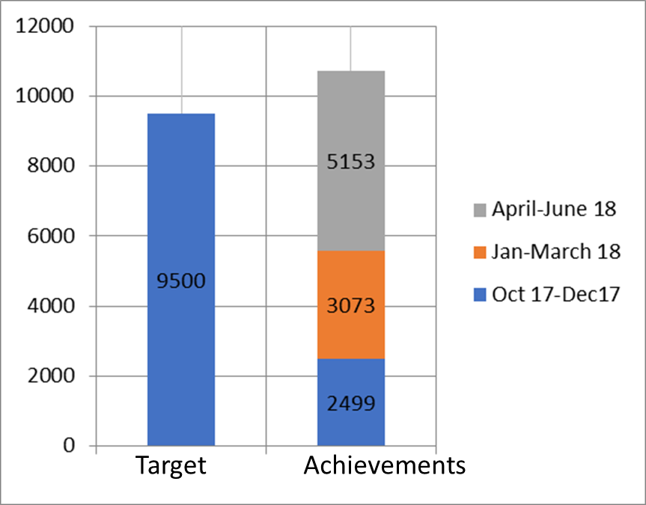
add source

Between October 2017 and June 2018, 10,725 GBV related services were provided to sex workers, which is 112% against the initial target of 9,500 services. The vast majority of services are provided by outreach teams at the hotspots where sex workers are provided with GBV prevention messages and first line of support to those who disclose violence. The uptake of services at the DIC is low compared to the one at the hot spots, a trend that persists over time.
Human impact and success story:
Joaquina is a peer educator from the community-based organization (CBO), ASCAM, who was trained on GBV prevention and response and has been sensitizing sex workers at hotspots on the types of GBV and coping skills. In one of her visits to a hotspot, she witnessed a scene of physical and psychological violence against a sex worker perpetrated by the sex worker’s partner. The partner had found out that she was a sex worker and not a fruit street seller as she had told him. He appeared at the hotspot with his friends and started to assault her in front of everybody. Joaquina was able to use the techniques that she had learned and with the support from the rest of the outreach team, managed to calm down the husband and convince him to leave the premises. Since the team effectively managed the situation, the police were not involved. Since then, Joaquina has kept in touch with the sex worker, forging a bond with her and helping her internalize that she does not deserve to be treated with violence. While the sex worker is still not ready nor in a position to leave her partner, she now knows that psychological and community support at the DIC is available to her by her peers for when she is ready.
Periodic presumptive treatment (PPT) of asymptomatic STIs
In 2016, the LINKAGES Project and the National Institute of HIV and AIDS (INLS) conducted a behavioural and biological HIV and STI prevalence study among key populations in five provinces in Angola. In Luanda, results indicated high rates of chlamydia (9%), gonorrhoea (10%), trichomoniasis (14%), and HIV (8%). thus many of the sex workers have been provided with information about the symptoms, types of STIs, and available services.

Sensitization Training with the police
The workshop was attended by a total of 34 participants:
- 11 heads of the municipal units for civic and moral education unit;
- 13 heads of the municipal victim’s support unit;
- 10 heads of the municipal domestic violence unit.

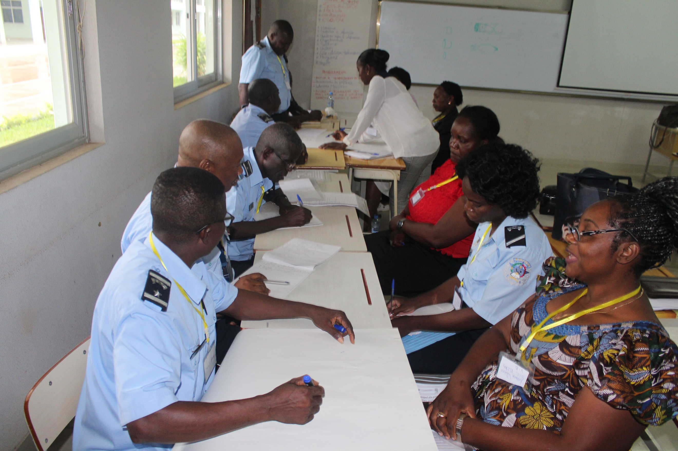
source

Question: Do you agree or disagree with the following statements? | Agree with statement |  | Disagree with statement
Statement | Pre | Pos | Pre | Pos
- “If FSWs are hurt while working, they are partly to blame” | 15% | 3% | 77% | 90%
- “If I could, I would choose not to provide services to homosexuals” | 22% | 1% | 62% | 97%
- “I understand the reasons why key populations can be more vulnerable to violence” | 85% | 97% | 4% | 3%
Table…
As can be seen by the test results, there were sharp changes in two statements. Participants went from believing that FS2Ws are partly to blame for the violence they can sometimes be subjected to (15%) at pre-test, down to 3% at post-test. Additionally, by the end of the training, close to all participants, 97% understand better the specific risks that key populations have.

On March 19 and 23 2018, the LINKAGES Project held the second round of trainings with police department chiefs of the various municipalities and districts in Luanda province. Due to a large number of participants, two sessions of one-day training took place on May 8th and 9th 2018. A total of 47 participants attended the workshops. The feedback from participants was quite positive; they recommended the training be extended to all police staff in order to create awareness on the issues about sex workers and key populations within the police as a whole. They also requested printed material to be shared with police stations.

“We want more trainings like this with all police patrol staff in order to provide them with knowledge, so sex workers are not mistreated anymore. Regardless of their occupation, they are human beings. One should not discriminate against them.”
Municipal Police Chief

SBCC messages using RapidPro SMS software
LINKAGES global has developed a system called Rapidpro that streamlines text messaging delivery on strategic contents such as GBV and health services. To raise awareness of the issue of GBV amongst FSWs and raise the demand for support, MSH has sent messages to 1500 sex workers who have previously engaged with the project. Each sex worker received the following messages:
“All types of violence women are subjected to are crimes, whether economic, sexual, physical or psychological. You have the right to live without violence. Seek help at Mwenho, a space for women, every Wednesday afternoon, at Samba, after Hotel Sunset. This is a message from LINKAGES Project in partnership with INLS, National Institute to Fight HIV, and UNDP.”
It was decided to make no explicit mention of sex work for the sake of security. Most sex workers’ partners are not aware of their occupation.

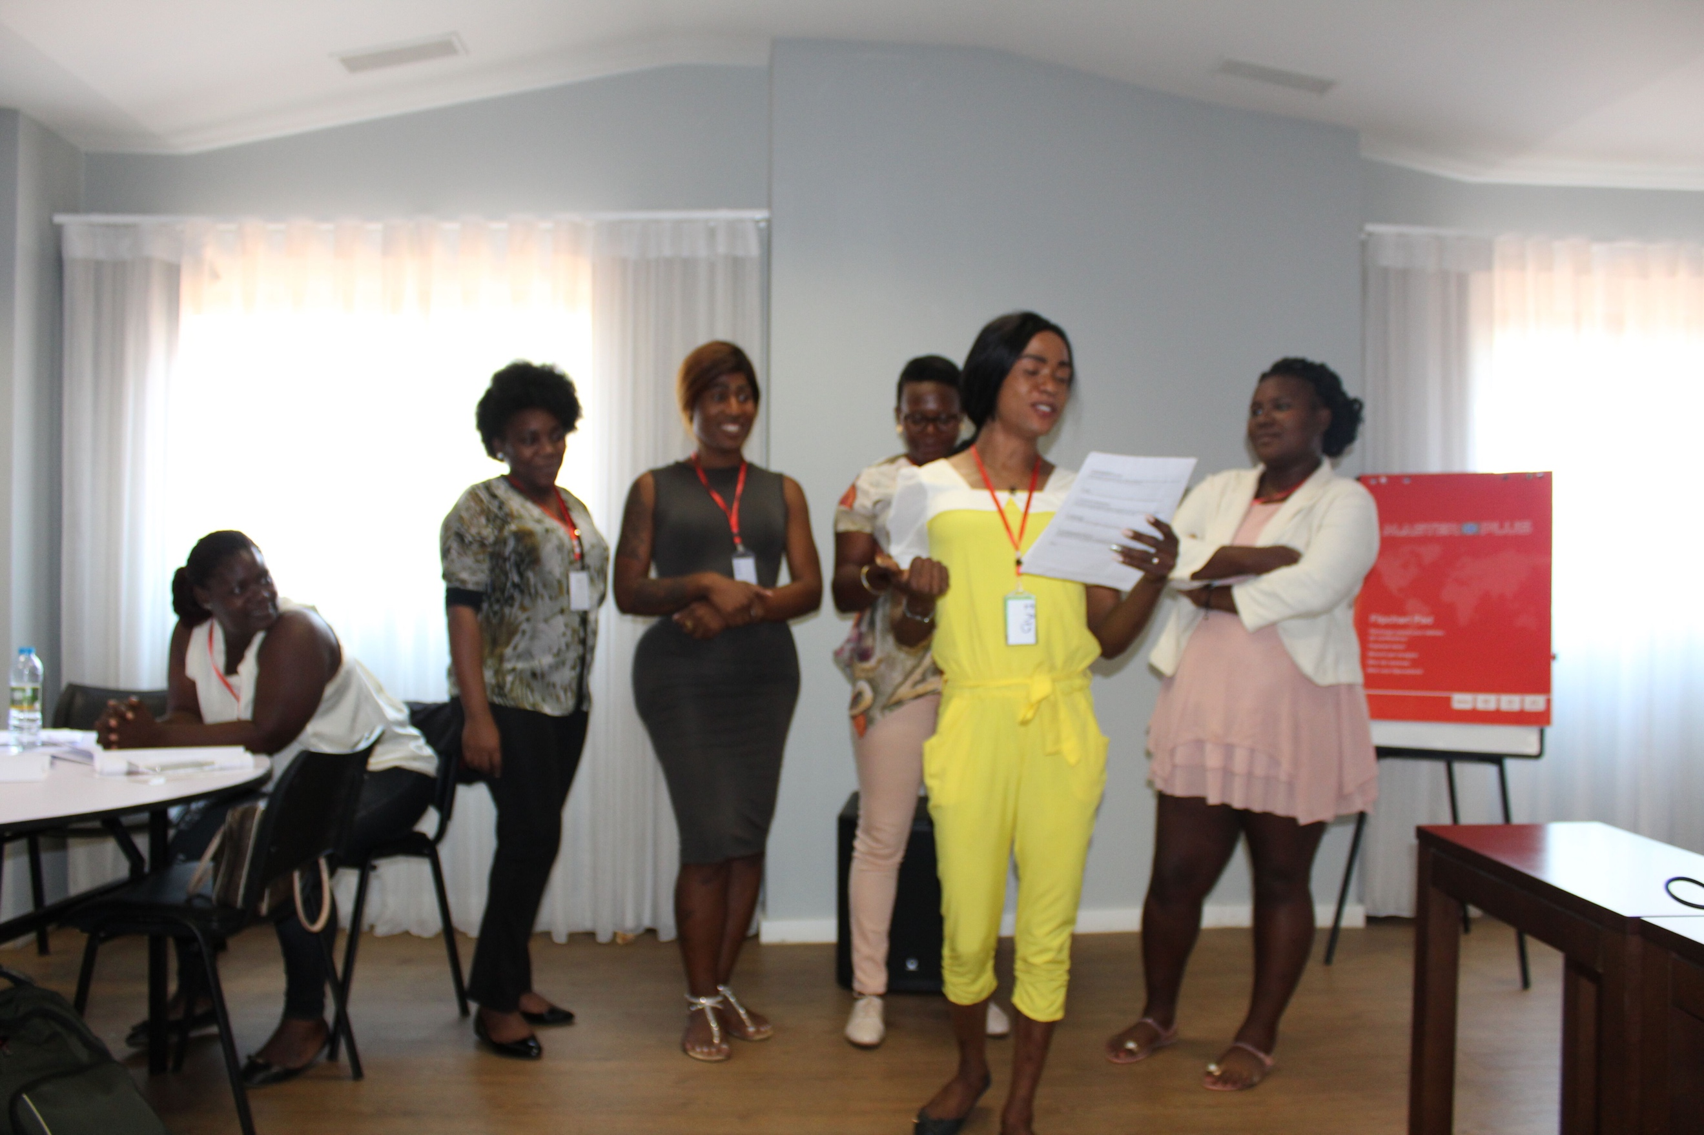
MSH workshop with FSW on SBCC

Challenges
- The main challenges of the project for this reporting period was the late start and late arrival of the Prevention Senior Advisor as well as the time it has taken the management team to learn how to fulfil financial disbursement requirements.
- Gender-based violence is not commonly recognized as a problem nor is it seen as such by FSWs.
- Initial low reporting of occurrences of violence.

Lessons learned
- The use of the theatre group to the LINKAGES work plan helped the outreach teams increase awareness and demand for GBV services among FSWs, clients and hotspot owners much faster and effectively.
- Great approval and customer demand for the flavoured condoms.
- Being a traditional institutional structure, police communication relies heavily on paper rather than email which takes a considerable amount of time. Projects need to adapt to police rules of engagement no matter how frustrating it can be.
- In Angola, police are one of the main perpetrators of violence against KPs, especially sex workers. MSH Angola strategy to approach the police was to request collaboration in the protection of vulnerable populations. Police should feel they are part of the solution of an important problem that they understand and can relate to.

- HIV prevention with men who have sex with men

Project description
The Communitarian Interaction Organisation (OIC), carried a project call “Ame a vida” (love life), focused on the prevention of HIV among groups of the key population, specifically men who have sex with men (MSM), within the five municipal regions of the province of Benguela: Benguela, Catumbela, Lobito, Baia Farta and Cubal. The duration of the project was from 01 December 2017 to 31 of June 2018. The activities set out by the project included:

- Registration of small groups.
- Carry out a number of activities with a Mobile Clinic in the places of concentration of MSM (in the municipalities) with the participation of the project STAFF (Peer educators).
- Hold reflection meetings with the key populations including the STTAF of the Project.
- Distribute 28,571 male condoms in the target group.
- Distribute 28,571 lubricants.
- Distribute 143 reference cards.

The project was presented to the partners, namely the Provincial Health Director, Municipal directors of Catumbela, Benguela Baia Farta and Lobito, with the participation of the HIV focal points from the aforementioned institutions.

Results
Positively, an open environment was established where MSM offered their opinions such as the difficulties in having access to health services and in other public sectors. Comments were also made regarding stigmatisation to MSM with society.

Challenges
- Lack of propaganda material for the field.
- Rupture of condom stock

Lessons learned
- Need to better and reinforce the communication between INLS and OIC.
- Implement actions with the female workers of sex for coming days, future activities.
- Great support for the availability of flavoured condoms by the MSM community.

IV HIV TREATMENT

- HIV treatment: health units
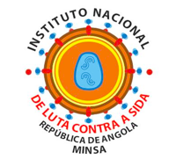
Project description
The National Institute for the Fight Against Aids (INLS) carried a project focused on sex workers, men that have sex with men, pregnant women, patients co-infected with TB/HIV and the general population. The project was carried from July 2016 to July 2018 with national geographic cover.

Results
Advocacy meetings took place with the NGOs, religious congregations, traditional leaders working in the community for the prevention interventions, treatment and HIV treatment. There were also advocacy meetings with the HIV focal points in GPL and prison services in order to reinforce counselling and testing strategy. ATIP training for 20 technicians in Luanda. The DVMAIP technicians gave training and overlooked the technicians from the sanitary units in the prior patient registration in ART in the new instruments as they would show up for their consultations. However, delays with implementing the project on time during July 2016 to June 2017 took place due to late recruiting of the MSM consultant, un-updated logistic supervision forms, lack of a system to handle the data from the notification forms just to mention a few of the issues. INLS results had tests, antiretroviral treatment (TARV), childhood precise treatment (DPI), and HIV/TB coinfection as its targets. There was a delay in the delivery of the tests acquired by the government. This forced INLS to restrict the distribution of tests nationally to avoid ruptures. Regardless of the issues, the implementation of the DHIS2 software still improved the acquisition, quality, quantity and improvement of the resulting reports sent by Luanda to INLS. Also, with the funds from the Global Fund, for transportation, there was improvement in the collection of samples and delivery of results at the health units. Furthermore, there was adhesion to the (HIV/TB coinfection) programme and to the new registration collection instruments to deliver the data concerning patients that initiated the treatment with prophylactic isoniazid for TB, by the health units.

Coverage indicator | Target | Results | Achievement
PMTCT-3: Percentage of infants born to HIV-positive women receiving a virological test for HIV within 2 months of birth | 800/  9540 | 1050/  9540 | 120%
TB/HIV-1: Percentage of TB patients who had an HIV test result recorded in the TB register | 36612 /  72685 | 20555 /  33805 | 120%
TB/HIV-3: Percentage of HIV-positive patients who were screened for TB in HIV care or treatment settings | 9500/  230000 | 8409/  230000 | 89%
TCS-Other 1: Percentage of children currently receiving antiretroviral therapy among all adults and children living with HIV | 6511/  32000 | 5604/  32000 | 86%
TCS-1(M): Percentage of people living with HIV currently receiving antiretroviral therapy | 111874/  359000 | 92623/  359000 | 83%

Title of graph

According to INLS’s director, Ms. Maria Lucia Mendes Furtado, some of the reasons for the disparities among the set targets and unreached results are:
- Registration problem
- Underreporting of the goal
- Issues during data collection in regards to the results
- Unidentified HIV/TB patients
- Lack of access by the people and to the people,
- Undiagnosed patients
- Issues with the system

Challenges
- Management of the funding from the Global Funds in excel programme.
- Delays in the recruitment process for a financial assistant.
- Lack of internet.
- SIS paralysed its data sending functions to INLS.
- Stoppage of the “SIS” in the provinces.
- Lack of reports and results being sent to INLS by the provinces of Lunda Norte, Cuando Cubango, Namibe, Moxico, Cabinda and Zaire specially during the January to March 2018 trimestral.
- Need in increasing the stock of fast diagnostic testing.
- Implementing the information system DHIS2 within all provinces.

Lessons learned
- Reinforce ATIP approach
- Reactivation of support groups for PLHIV. Similar to PAFs, GAMs, NGOs, etc.
- Create a support line with the sanitary units (distribution of tests and IEC material and information gathering).
- Better integration between HIV, SRH and TB.
- Greater number of SRH services in testing.
- Audit patients in ART
- Need for INLS and the provincial services, with the help of its partners, to continue pushing for quality improvements in the programme among all levels of it.
- Update the doctors in relation to the new therapeutic norms.
- Inform the population about HIV/AIDS (transmission, prevention) using wider diffusion means (radio and television) in a periodic way.
- Need to update and organise clinical processes and books.
- Improve registration of funerals and abandonments with the new instruments.

- HIV treatment: community interventions
Project descriptions
- The Salvation Army (TSA) carried its programme from October 2017 to June 2018 with a geographical focus in the provinces of Lunda Sul and Lunda Norte. The targeted groups were the population in general in order to reinforce the answer against HIV/AIDS in Angola.
- Africare carried a project with the geographical focus in Moxico with the duration from December 2017 to June 2018 focused on men and women older than 15 years of age, pregnant women and PLHIV and TB.
- OHI carried the FRN- SIDA EM ANGOLA project, a 9-month long programme implemented on the 23rd of October 2017 to the 30th of June 2018, in the geographic area of Benguela, mainly in its municipal areas: Baia-Farta, Cubal, Catumbela and Lobito. The aimed groups were patients with HIV, TB, pregnant women, children under the age of 5 years old as well as the general population in the communities under the project’s intervention.
- MWENHO’s programme was focused on the general population within the ages of 15 to 45 years of age, targeting the provinces of Bie and Luanda. The campaigns sensitized the beneficiaries and sent to the referral center for HIV testing, and condoms were distributed in the municipes of kuito, Chinguar cunhinga, …look at luanda’s one (needs checking)
There were a number of questions in regards as to:
• Why in a relationship, one of the partners can have HIV and the other one wont?
• If the result is positive and in fact I do not have HIV / AIDS what attitude should I have?
Women were the ones who most requested clarification, as well as acquiring the condom.
The campaigns were made from the method of interpersonal communication (CIP), informal conversations with the population.
- Ajuda de Desenvolvimento de povo para povo (ADPP) focused its project in the provinces of Kuando Kubango, Kunene, Huila and Namibe from 23rd of October 2017 to 30th of June 2018. The project was carried with health units across each municipal area and capital of the 4 provinces. At its beginning stages, the programme based its activities on administrative organisation, introductory meetings, and the creation of visibility of the provincial governmental, municipal, and traditional authoritarian sectors and structures.
- The Agencia Piaget para o Desenvolvimento (APDES) carried a project during October 2017 to June 2018 in the province of Bie focusing on pregnant women, PLHIV, people with TB; and nursing and community students.
- Obra Divina Providencia (ODP) project carried a project targeting the community in the provinces of Luanda, more specifically in the municipal areas of Kilamba Kiaxi, and in the province of Benguela, the municipal area of Cubal. The project duration was from July 2017 to June 2018.
- Centro de Apoio ao Jovens (CAJ) carried its activities during October 2017 to June 2018, focused on pregnant women, PLHIV/AIDS/TB, Malaria, in the provinces of Luanda and Kwanza Norte.
Results
The NGOs worked closely together with UNDP to review and adjust the performance and targets. The training and qualification of activists and interns took place with increase in numbers throughout the projects. Many of the project benefited from the number of advocacy meetings in all health department levels with unconditional logistic support, primarily in the supply of condoms. For projects such as the one from TSA, the resulting amounts distributed over reached expectations, due to such mobilisation and education events that took place at fairs, schools, public transportation stops, churches, health units and the community from the geographic focus. In regards to the informative material, large number of the targets were reached due to the contribution of various actors. Leaflets were distributed, with INLS contributions of informative leaflets, posters and the rest were from the provincial and municipal health sectors. Some of these informative products, took the care to have a specific focus on religious leaders of the communities, therapists, midwifes and the community in general. Aslo, social media platforms such as Facebook pages were created as further means reach and interact with the population, with the aim of communicate, educate and inform about HIV/AIDS.
DPI was the area with the lowest results by some of the projects due to the lack of proper diagnostic tests in the provinces. The health units also had a low result due to a lack of information in data base, deriving from confidentiality reasons (PLHIV require a great amount of discreetness, in order to obtain gradual trust from them). Nevertheless, some of the NGOs implemented an external reach system for the communities in risk situations. This was done through activists based in the areas with mines such as Catoca and Lucapa, to the truck drivers leaving their stops, and to the female sex workers. This enabled the identification focal points where there is a flux of sex workers.
For the prevention of mother to child transmission (PMTCT), the number of HIV positive pregnant women that received at least one type of community based PMTCT services (GAMs, referral to PMTCT services, counselling for SRH services) was also successful with the results over reaching the set targets. The results of some of the programmes had some negative outcomes on the ability to have access to HIV testing services to the beneficiaries within the communities. These issues were logistical consequences of the public health programmes. Another element was the identification of the beneficiaries themselves, who lived in extreme poverty, PLHIV, unfortunately in certain cases, they would quit ART medication due to lack of food, also in highlight of their social vulnerability status.
In regards to HIV/TB, although the numbers were small, there were various activities carried in the communities, as well as within the institution such as the health units, public and private schools, home visits and interpersonal communication activities. Alcoholism and Tabaco/cigarette smoking were also themes discussed due to some of the beneficiaries being drinkers and smokers and still do not take the medication correctly.
In addition, UNDP paid visits and had a first-hand interaction with the activists and other actors in order to be fully embedded in the project.

Success stories/ Life impact
- Delfina Elombo, I have been living with HIV / AIDS since 2006, my husband accused me that I was the one who transmitted the disease and expelled me from home with 4 children and had nowhere to go. A lady welcomed me and gave me a room to live and after knowing that I was an HIV-positive, the lady also expelled me. I had nowhere to go when I explained my story to MWENHO-Kuito's coordinator who then got me a one-bedroom house and paid the rent.
After a while, MWENHO contributed some money to do business, and I started to sell things. One day when riding motorcycle I had an accident and lost my right leg. During that time my baby started getting sick and when some tests were made, I found out it was because my child was also HIV positive. I did not know what to do with my life. But if it wasn’t for the Mwenho activists who helped me, I do not know what would have become of me without them, I would not have lived. I think this project should not stop, because it is saving many lives.

Kuito on 12 December 2017

- OHI’s credibility as an institution experienced an increase due to having an intervention that in some way is in accord, or complements the actions taken by the national executive of Angola, highlighting the recent HIV-AIDS strategic plan. Adolescents over 15 years of age that have been mobilised within the communities that experienced the projects intervention, now go to the HIV counselling and testing services even without the presence of the health community agents. This contributed greatly to the increase in the change of behaviour and individual responsibility in the preventive health framework.

- The collaboration with the local healers and traditional therapists had successful outcomes. During the project, TSA received two phone calls from the traditional therapists from Locapa and the other from Saurimo where they asked for the referral of their patients for HIV testing. This happened after successive workshops that took place at the start of the June that combined the traditional midwifes, pastors, leaders and other influential individuals from the community. This shows that the traditional healers and therapists are starting to understand the need to separate traditional diseases from the ones caused by AIDS.

Challenges
- Logistically, there were challenges with the transportation due to some lack of fuel in the targeted provinces.
- It was challenging implementing the transportation for the supervisors.
- From an administrative point of view, the biggest challenge was the lack of a regional office for some of the NGOs
- Internal issues that affected reaching the targets. For example, the Sanatorio hospital only permitted one day a week for the activities to take place.
- Weak, and dehumanized public service.
- Getting other partners to do complementary actions for long term positive results.
- There is a weak follow up procedure of the HIV positive women by the nurses from the health units.
- Struggles to reach HIV positive people who also have TB symptoms also made it difficult to refer them to TB services.
- Insufficient tests and condoms and IEC material for the distribution.

Lessons learned
- The community involvement is key for the success of any project.
- The adhesion rates are very low compared to the number of HIV positive individuals, merely due to the still high levels of stigma and discrimination and fear of such. It is important to continue mobilisation campaigns with traditional and religious leaders support.
- Time counts to the success of a project. The fact that the programme took to set off, influenced the final results. More time would be necessary to consolidate the results.
- The beneficiaries such as female sex workers welcomed the services offered by NGOs such as TSA which shows that the programmes elaborated with the focus on them can have successful results.
- Some of the projects needed a better means of transportation to have more positive results.
- The weak institutional collaboration that existed among the public and private institutions and the civil society organisation (CSOs) benefitted and experienced improvements due to the activities carried by the community health agents.
- Small constraints, as the period of student holidays occurred during some of the intervention time. Therefore, the activities took place in the squares, markets and taxi stops. For this reason, it was impossible to reach some of the goals of the coverage indicator for some of the NGOs (MWENHO).
- Working with PLHIV who give their testimony and counselling to others is indispensable.
- Involving local authorities, traditional and religious leaders is an advantage.
- Activists and counsellors that speak the traditional local languages facilitated the communication.
- Some of the HIV positive pregnant woman adhere to the PMTCT programme, whereas other simply disappear. Therefore, the efforts now need to be focused on the mutual help groups (GAMs), and intensify the already existing GAMs to reduce the risk of transmission.

V PROCUREMENT & SUPPLY MANAGEMENT

Solar for health (S4H)
With the objective to ensure quality of HIV medical products throughout the entire supply chain, UNDP proposed to assess and implement a Solar for Health (S4H) project in Angola. It is the main activity proposed at the Quality Assurance Plan and the intention was to start with a solar PV pilot project in one provincial warehouse to provide enough and uninterrupted electricity to guarantee appropriate storage conditions in the supply chain of pharmaceutical products for health facilities and to cover the energy needs during the blackouts, as well as reducing dependence on the national grid or diesel generators. In addition, the solar energy system will contribute to reducing the presence of carbon in the atmosphere.
Although Angola is classified as a high medium income country, its human development index is 36,6%; putting the Country in the category of Low Human Development. The country current situation on this sector shows relevant gaps, such as:
Availability: Below 40% of the population currently have access to electricity; with 70% being in the city of Luanda. Health and education infrastructures outside of Provincial Capitals still have limited access to energy services.
Reliability: Infrastructures for power generation and distribution are not able to cover the current demand, resulting in frequent blackouts and many customers - domestic, service or industrial - use diesel based backup generators to cover their needs.
Affordability: although is low compared to other sub-Saharan African countries, the diesel price was increased from 40 to 75 kwanzas per litre, due to a political decision.
Sustainability: Utility power generation is mainly based on diesel and the electricity tariffs cover less than 20% of the electricity costs, resulting in a deficit situation for the sector utilities.

On the other hand, Angola possesses substantial renewable energy resources and solar energy constitutes the larger and more evenly distributed renewable resource of the country with an annual average of 1.350 and 2.070 kWh/m2 yearly global horizontal radiation.

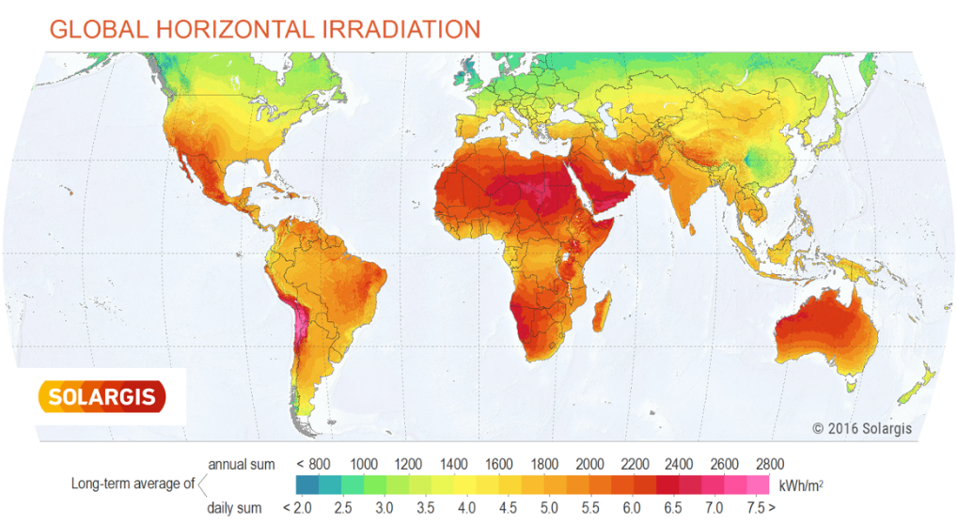
Figure 2. Global horizontal irradiation

Process
The Project was designed in two phases:
Phase I: Technical evaluation of two provincial warehouses (i.e. Luanda and Cabinda), to assess the potential implementation and use of solar PV generation Identification, assessment and selection of the Pilot units, as well as the installation of the respective panels (March-December 2018).

Phase II: Replication of the Project in additional provinces (Benguela, Lunda Norte, Moxico and Cuando Cubango (April 2019 - the end will depend on the availability of resources and subsequent negotiations). However, two additional provinces were definitively selected: Moxico and Cuando Cubango.
The process was carried out by a multi-sectoral team of the Ministry of Health of the Government of Angola and UNDP, which uses as evaluation criteria the following variables:

1. Stability or suitability of the structure
2. Security of Infrastructure and surrounding area
3. Availability of space for system panels and equipment
4. Existing electrical equipment
5. Electricity consumption requirements
6. Physical or structural conditions of the building
7. Area covered by sun during the day
8. Energy saving measures

Results
According to the final results of the Assessment, Luanda and Benguela are the provincial headquarters who have the warehouses that correspond to the main technical requirements, namely, a) Space for panels available; b) only limited repairs needed; c) most limited sources of electricity; d) good sun conditions.

VI NATIONAL CAPACITY BUILDING

- INLS
- Capacity Development Planning Process Plan
Context
Angola has received a total of US $ 215.7 million since 2005 from the Global Fund to Fight AIDS, Tuberculosis and Malaria (GFATM). The first grant to Angola (Malaria Round 3 in the amount of US $ 35.0 million) has become effective in April 2005 with UNDP as Principal Recipient (PR). In the same year, 2 additional grants managed by UNDP came into force, TB Round 4, on August 1, 2005, with an approved amount of US $ 10.3 million and HIV Round 4 on October 1, 2005, with an approved amount of US $ 86.1 million.
As Principal Recipient, UNDP has designed and implemented a plan to strengthen the capacity of the Ministry of Health (MINSA) to assume PR responsibilities. MINSA became the PR for the first GFTAM (Malaria Round 7) grant in November 2008 and for the TB subsidy in 2011. For the day-to-day management of the GFTAM grants, MINSA has set up a Technical Management Unit within the Cabinet of Studies, Planning and Statistics (GEPE).
In 2015, the National Coordination Mechanism (CCM) of Angola requested funding from the Global Fund under the New Financing Model (NFM) to support the objectives of the national HIV / AIDS plan. prevention of new HIV infections, increased coverage of prevention of mother-to-child transmission (PMTCT), increasing numbers of children and adults receiving treatment, and increasing numbers of patients enrolling in antiretroviral therapy ) in Angola.
These objectives will be achieved by improving the provision of prevention and treatment services, by extending surveillance activities and by improving the monitoring and evaluation system. Although PMTCT is the first national priority, the Global Fund also supports other national priorities related to HIV prevention interventions targeting young women and adolescents. The grant also includes HIV prevention interventions among key populations and improved services for diagnosis and treatment of TB and HIV co-infection.
The UNDP as the interim PR for the newly approved grant has the National AIDS Institute (INLS) as the main Sub-Beneficiary in its implementation. During the implementation of this grant, UNDP shall ensure that there is transfer of capacity and provision of Technical Assistance to INLS as well as other Sub-Beneficiaries participating in the implementation of the grant. To achieve this goal, UNDP is in the process of developing the Capacity Development Plan to strengthen INLS 'knowledge of the GFATM processes and improve its performance in the implementation of HIV programs.
Process
Workshops: Capacity Evaluation Workshop
In order to facilitate the capacity assessment process, a workshop was held on April 20, 2017 to:
- Analyze the challenges, risks and opportunities for the implementation of Global Fund programs and grants.
- Joint definition of an action plan to respond to identified challenges, mitigate risks and achieve the desired impact
- Define together the priorities and activities to be included in the Capacity Development Plan for INLS.

Participants included INLS representatives, United Nations agencies (UNFPA, UNDP, UNAIDS), Ministry of Health (DNSP), CCM Secretariat, Civil Society Organizations (ANASO, IRIS, ADPP, Mwenho, CAJ).
The workshop allowed participants to discuss the minimum requirements for PR role performance and to present experiences that can be used as examples in the INLS capacity development process.
Workshop participants were divided into three groups - program management and M & E, financial management and Procurement Management and Distribution Chain (PSM) - to discuss existing gaps in these areas, priority actions and activities to address capacity gaps identified.

Product
The capacity development planning process includes summary of the INLS capacity assessment, the priorities for the Capacity Development Plan and the description of the Capacity Development planning process.

- Financial Management Software Solution
Requirements and Specifications
Context
Following INLS’s evaluation carried out in mid-2016, and after discussion with the Local Fund Agent (LFA), it was agreed to acquire and install a solid accounting system in INLS for the management of funds from external donors, Global Fund (FG), and thus replace the national accounting tool which were not flexible and adaptable, as well as the Excel worksheets that were used.
Process
Several discussions were held with donors and INLS in order to select appropriate accounting software. The selection options for an accounting system in Angola are reduced due to two orders of factors, such as:
- There are not many accounting systems available in Portuguese.
- Few accounting systems can adjust to work with the national accounts plan.

The financial operations of INLS are not complex, so a system like MICROSOFT NAVISION is too complex to meet the needs, as well as being quite expensive.
The system that should have been installed after the first discussion was SAGE, given the relative ease of financial operations. However, only two companies were identified for their installation - one that did not respond to the invitation to tender; and one that, after initial discussions and presentation at INLS, showed no responsiveness or customer orientation.
The selection of the financial management system was interrupted with the change of the Head of Financial Department. The new Deputy Director of the Joint Services (Directora Adjunta dos Serviços Agrupados), responsible for this area, did not know the INLS thus choosing to gain first management experience in the institution.
Initially, INLS also intended to have a defined internal control structure and operational procedures well implemented, and later introduced an accounting system. In this context, a consultant was recruited for the development of these activities, which have already been initiated.

Product
New discussions were held with NGOs, partner entities and stakeholders, which led to opting for the "PRIMAVERA" software, based on the following:
- It is the most used accounting system in Angola, so it is available locally, by national experts, to users, super users and implementing companies.
- It is available in Portuguese and according to the Angolan legal accounting structure.
- The Global Fund Task Force in the Ministry of Health uses the same system.
- The "PRIMAVERA" software has good reporting options.
- Various modules can be purchased, including procurement, heritage, logistics and HR.

- HIV GFATM Grant in Angola- Organizational Sub-Receiver Capacity Assessment Report
Context
Sub-Recipients (SRs) play a crucial role in the implementation of Global Fund to Fight AIDS, Tuberculosis and Malaria (GFATM) programmatic activities and the management of grant resources. The National Institute for the Fight Against AIDS (INLS), of the Ministry of Health, is the main national and governmental agent in the fight against HIV / AIDS in Angola. In addition to being a SR of the HIV grant since 2005, INLS is also an important body in the definition of policies and medical protocols by the Angolan government and has played a key role in the development of the synthesis document on HIV based on the National Strategic Plan for HIV / AIDS 2015-2018.
In accordance with UN procedures, INLS underwent a HACT evaluation by Deloitte in March 2016, which had a satisfactory result in that it pointed to a moderate risk of UN involvement in INLS operations. In October 2016, Deloitte's assessment was in the process of being finalized. The current assessment, in accordance with UNDP and GF procedures, has been further developed in relation to the processes associated with the GF project.
INLS and UNDP have collaborated closely during the NFM HIV subsidy. The activities focused on were M & E systems and visits, training and teaching events and materials, training and communication, strengthening of procedures and systems, as well as consultancies to support the core functions of INLS.

Process
The following objectives have been defined for capacity assessment:
- Determine the ability of INLS to perform SR functions and manage the Global Fund grant in accordance with the objectives and time frame of the grant.
- Determine if INLS has the management capabilities needed to implement and manage new programmatic activities.
- Determine whether INLS has adequate measures to ensure transparent management of resources
- Identify and understand the main capacity gaps related to INLS operations in the context of programming and financial management.
- Identify the specific capacity development needs of INLS.

Capacity assessment had two phases: a first phase of self-assessment by INLS staff; and a second phase of UNDP review of the most important processes identified during the self-assessment and interviews.
UNDP conducted this evaluation as the Lead Recipient of the grant. The evaluation was involving the INLS staff, both in the administrative area and in the program area of ​​the institute.

Product
Analysis of the above components led to the conclusion of a positive assessment with reservations, ie INLS may be a SR of the HIV subsidy, but improvements and risk mitigation measures should be implemented during the life of the grant.
UNDP and SR will seek to address capacity gaps identified through a capacity development plan under the agreement or through specific payments as risk mitigation measures.
In addition to assessing the minimum requirements, a DACTEL assessment by Deloitte in 2016, commissioned by the United Nations System, indicated a moderate risk in general for INLS activities.
On the other hand, the factors influencing the current situation in INLS are:
- The recent abrupt changes in the economic environment of Angola, outside the scope of influence of INLS.
- Changes of staff from the administration unit in October 2016, thus the new staff members are not yet experienced in the SR function.
- Numerous new activities, some of them never before carried out by INLS and not covered by INLS operational procedures.
The above factors have been taken into account in the preparation of the risk management plan.

In addition to aforementioned, INLS also has other documents that reinforce their capacity building such as:
- Manual of Operational Procedures of INLS - National Institute for the Fight against AIDS
This document aims to systematize and formalize the standards of action related to operational activities identified in INLS - National Institute for the Fight against AIDS.
to ensure the coherent and consistent execution of relevant activities of an operational nature, in order to enhance INLS's good organizational performance and to obtain the results outlined, as well as communication between the areas and effective management of grants from the Global Fund and other external donors.
- Operational Guide to the Internal Control Structure of INLS - National Institute for the Fight against AIDS.
This document sets out the Operational Guide for the Internal Control Structure of the National Institute for the Fight against AIDS (INLS), in order to document the internal control structure and guide its implementation and conduct in an effective way, providing reasonable and sufficient assurance that assets are safeguarded, information of a financial and other nature is reliable, current legislation, standards and policies are met, and that offenses and errors are avoided.

- NATIONAL PMTCT
- Plan of Elimination of Vertical Transmission HIV 2012 – 2015
Final Plan Review Report
Context
Angola developed its Plan for the Elimination of Mother-to-Child Transmission of HIV 2012-2015 as a national priority in 2011. The final evaluation conducted by UNAIDS and other partners in 2016 showed that among the priority countries, Angola had lower results than expected.
The country aims to be part of the countries that have eliminated mother-to-child transmission, not only of HIV, but also of congenital syphilis and Hepatitis B. It is in this context that Angola reviewed the 2012-2015 ETFM Plan as a crucial step to develop the new 2018-2022 plan.

Process
The review of the ETMF 2012-2015 Plan was inclusive and participatory; the combination of several approaches has enabled the triangulation of information, the identification of bottlenecks and their causes, and the formulation of realistic recommendations that are more aligned with the country's current context.

Product
Despite the efforts made by the Government and its development partners, the results in 2015 were below the targets:
- The new pediatric infections have dropped only 24% instead of the 90% predicted;
- The mother-to-child transmission rate was reduced from 35%, from 32.5% to 21%;
- Access to ART for pregnant women increased from 21% (from 33% to 40%);
In 2017, we see a regression of the indicators compared to 2015:
- Increased new pediatric infections by 28% from 4300 to 5500 (Spectrum estimates);
- Increase in HIV MTC of 24% (26% in 2017 as against 21% in 2015 / Spectrum);
- ART coverage of pregnant HIV + dropped by 15% (34% in 2017 vs. 40% in 2015).

However, important efforts have been made to improve access to HIV prevention, care and treatment services by expanding services, training health workers, providing inputs, materials and equipment.

- A Future Without HIV / AIDS
National Plan for the Prevention of Mother-to-Child Transmission of HIV, Congenital Syphilis and Hepatitis B, 2019-2022

Context
Angola, one of the priority countries in the "Free Start, Stay Free, AIDS Free" global strategy, aims to eliminate HIV as a public health threat and to achieve the 2030 global goals.
With a mother-to-child HIV transmission rate estimated at 26% (INLS, 2017), PMTCT is a national priority to ensure a generation without HIV / AIDS. It is in this context that INLS, in its role as coordinator of the multi-sectoral response, conducted, with the support of the UNDP / Globa Fund and other partners, the review of the ETMF 2012-2015 finalized plan and the preparation of the new PTMF 2018-2022 plan , less ambitious, but more realistic.
Implementation will be guided by the following guiding principles: (i) Effective HIV integration in MNCH services; (ii) Institutional and individual accountability of the response to mother-to-child transmission of HIV, syphilis and hepatitis B; (iii) Human rights inseparable from an effective response to HIV and (iv) Sustainability of the HIV response in general and the PMTCT in particular, by increasing the domestic contribution and diversifying partnerships.
General objectives
• Reduce new pediatric HIV infections by 60% by 2022.
• Eliminate congenital syphilis by 2022.
• Reduce mother-to-child transmission of hepatitis B.
Specific objectives
• Increase condom use by 15-24 year olds from 33% (f) and 42% (m) to 65% (f) to 70% (m) by 2022.
• Reduce HIV TMF by 26% to 9% by 2022.
• Improve the quality of pediatric care by 2022.

HIV prevalence between 15 and 49 years according to province

Source : IIMS 2015 - 2016

Process
To achieve the objectives, the plan is subdivided into parts:
- Primary prevention encompassing pillars I and II of the PMTCT, namely primary prevention of HIV in particular in adolescents and young people, and prevention of undesirable pregnancies in HIV + women.
- Prevention of mother-to-child transmission of HIV, syphilis, and hepatitis B is based on systematic testing for HIV, syphilis and hepatitis B HIV. Dual HIV / syphilis testing is recommended. Testing of HIV negative pregnant women in other NB, delivery room and during breastfeeding is one of the other strategies. The NPC will be the gateway for family access to HIV prevention, care and treatment services through screening of direct family members (family-centered approach or index case). Improving the retention of the double mother-child to the definitive diagnosis is another ploy.
- Pediatric treatment aims to increase the number of seropositive children who are aware of their own serological status through the use of ATIP and HIV testing campaigns targeting this group. Integrating HIV into the MNCH platform will strengthen children's access to HIV prevention, care and treatment services.
Improving the quality of comprehensive care for HIV + children and adolescents is another objective of this plan. It is about implementing friendly services for HIV children and adolescents through a pilot project, whose results will serve to review the services made available to this particular group.
- Cross-cutting areas composed of effective and efficient SRH / HIV integration, combating stigma and discrimination, strengthening the HIV supply system and strengthening the monitoring and evaluation system.

- Workshop for the Elaboration of the National Plan for Elimination of HIV Transmission from Mother to Child, Congenital Syphilis and Hepatitis B, 2018 – 2022, on the 27th of June of 2018
Promoted by the National Institute for the Fight against AIDS (INLS), funded by the United Nations Development Program (UNDP) under the Global Fund. The opening session was chaired by Dr. Graça Manuel, Head of the Clinical Support Department of INLS, representing the Director General of this Institution, Dr. Maria Lúcia Mendes Furtado. In the presidio, Dr. Graça Manuela was joined by Dr. António Coelho, Executive Secretary of ANASO, Dr. Mamisoa Rangers, Coordinator of the UNDP / FG Project and Dr. Michel Kouakou Coordinator of the United Nations Organization to Fight AIDS ( UNAIDS).
In all, 15/18 provinces were represented, and due to calendar reasons the provinces of Cabinda, Malanje and Moxico were absent.
Dr. Graça Manuel, Head of the Clinical Support Department of INLS, representing the Director General of this Institution, Dr. Maria Lúcia Mendes Furtado considered vertical transmission as the great constraint of INLS and the integration of all Provinces in this exercise. By explaining the importance to the whole country of this problem, given the high transmission rate of 21%; Dr. Graça stressed the need to work together to minimize this situation. In 2017, there was 31% coverage of prevention services, too little to be effective. Much has already been done which leads us to question the way we have been doing things. She considered that we are all responsible for what happens due to non-compliance of established protocols and norms and the weaknesses in the follow-up of women tested positive during the Pregnancy-Childbirth-Post-Stroke process, which are the three crucial moments of transmission. One must reflect on how to improve services to break the chain of transmission. Ms. Graça said that the Plan in preparation will precisely serve as a daily itinerary for the effect in order to achieve the goals contained therein.
Also, Ms. Mamisoa Rangers, Project Coordinator UNDP / FG expressed the concern of the Institution and all financial and development partners, given the high rate of transmission from mother to child of HIV in Angola, which led to the hiring of an International Consulting, Ms. Andrea Robalo, to facilitate this exercise of revision of the previous Plan and elaboration of a new National Plan in order to reverse the trend of said Rate of transmission.
On behalf of UNDP, the importance of this United Nations System Agency was emphasized. The involvement of all civil society organizations, key or vulnerable populations and partners, in this extremely important exercise for the country. Furthermore, it was reminded the focus in this new Plan for the issue of gender, the family, the problem of stigmatization and discrimination towards the people and families that live this reality. Ms. Rangers then ended her intervention wishing success for the work.

- Legal Environment Assessment (LEA)
Context
The LEA is a HIV regional project for the reduction of the HIV risk and the improvement of sexual and reproductive health of the young key populations in southern Africa, embedded of a consolidated assessment of the legal environment in Angola.
Angola is among the countries in the Southern African region, with the lowest characterized rate of HIV, with an overall prevalence ranging from 2% to 2.35% in adults aged 15-49. Notwithstanding Angola's low rate, the quoted percentage still represents a high number of HIV-positive people.
The prevalence in women is 2.6% and in men it is 1.2%. In young people aged 15-24, the prevalence is 0.9%, being relatively higher in women with 1.1%, and in the age group 20-22 the prevalence is 2.1%. And although the Angolan population is young (with the average age of 21 years), life expectancy is reduced, as it is generally 60.2 years, for men 57.5 and for women 63.0.
Regarding the prevalence by provinces, the data point to a higher incidence in the southwest region, especially Cunene province with 6.1%, Cuando Cubango with 5.5% and Moxico with 4.0%. On the other hand, the provinces of the North of the country present the lowest prevalence, with Zaire registered 0.5%, Cabinda 0.6% and Uige 0.9%.
The provinces of Lunda Norte, Lunda Sul and Luanda are also in the list of provinces most affected, the last one, with about seven million inhabitants, is the most populous in the country.
Therefore, it is estimated that more than 24,953 people live with HIV / AIDS based on a prevalence of 2.35% in the general population. Among the currently controlled HIV positives, 23,032 are adults and 1,921 are children. In the list of adults are 18,795 people and 1,468 children who started antiretroviral medication.
The prevalence of HIV is relatively more pronounced in young people because of the lack of life experience, age-specific behavioral attitudes, and resistance to comply with HIV prevention recommendations. vulnerable. Alongside these are orphans, street children, people with disabilities, discordant couples, refugees and migrant workers (truck drivers, miners, militarized forces).
In view of all this, activities to provide HIV prevention, treatment, support and care for people infected with HIV and AIDS, funded primarily by the EMB, the Global Fund, and other small-scale partners, including the Bank World Bank and United Nations Agencies.
This effort has also been manifested in the legal field, for example, Angola approved in 2004 a law on HIV and AIDS to contribute to the response to the epidemic. Before the (HIV / AIDS Act), the regulation on the work and professional activity of people living with HIV / AIDS was created and approved.

Process
The LEA in Angola took a health and HIV approach in line with human rights and international and regional commitments, whose recommendations aim to contribute to reducing the impact of HIV / AIDS on key populations. It worked by offering a descriptive outline of the different and relevant international norms, national and regional human rights frameworks, serving as a critical and analytical comparative backdrop to the legal and political regulations in Angola.

The methodological route for the evaluation of the legal environment focused on:
- Bibliographic or documentary research: review and implementation of existing laws, regulations, recommendations, reports, directives, protocols and policies related to the protection of Human Rights and HIV;
- Jurisprudential analysis: research and study of decisions involving people living with HIV;
- Interviews, questionnaires, national consultative dialogue (National Workshop) key populations, vulnerable people, public institutions, and CSOs.

The topics covered were:
- Anti-discrimination and equality laws
- Legislation, politics and health plans
- Criminalisation of the transmission, exposure and non-disclosure of HIV
- Women, gender inequality, harmful gender norms and gender based violence
- Children and adolescent
- Key populations
- Employment
- Social security
- Refugees, asylum seekers, stateless persons and migrants
- Education and Information
- Access to justice and the law

Each of the eleven discussed topics mentioned above were segmented into:
- Situational analysis
- International pattern
- Present situation in Angola
- Gaps and challenges
- Recommendations
It was important to segment the information in such form in order to offer a clear depiction of the legal environment internationally and nationally, to result in a true grasp of the gaps, challenges and provide realistically concise recommendations for each of the topics to better serve the situation in Angola.

Product
Main tasks of the LEA:
1. Initial Report: text / base document that guides the entire evaluation process and establishes a clear plan of action for the evaluation of the national legal environment, integrating all previous discussions and deliberations, such as the outcome of the Consultative Planning, national dialogue and meetings of the Technical Working Group. (concluded)
2. Preliminary Report: Includes the review of all existing laws and documents in the country on HIV, DH and the improvement of sexual reproductive health of the key youth populations.(concluded)
3. Report on the interviews and validation of the study (national workshop): this translates into the outcome of the interview phase and consultation and discussion of focus groups with key populations and stakeholders comprising the State Institutions (Parliament, Courts , the republic's attorney general office, ministerial bodies), CSOs and other participants and their validation by all.(concluded)
4. Final Report: Overall Outcome of Desk Review with interview reports and focus group consultations, as well as final recommendations, approval and advocacy. (under process)

- Engagement Scan (ES)
Context
The purpose of the engagement scan (ES) is to provide a tool for CSOs working on HIV and sexual and reproductive health (SRH) rights to plan for and strategically engage and advocate for legal and policy reform and action where gaps and challenges have been identified while at the same providing opportunities for strengthening existing mutually-beneficial partnerships with government and other relevant key actors in the country in the formulation, adoption and implementation of appropriate action. The ES is aimed at assisting CSOs plan for and engage in legal and policy reform. It provides a legal and policy background, background on the various institutions relevant for legal and policy reform, particular processes for legal and policy reform and specific key opportunities for which CSOs can plan.
There is insufficient knowledge of HIV and AIDS among people in Angola. Data collected by the National Institute of Statistics tells that the vast majority of men and women aged 15-49 have heard of HIV/AIDS (82% of women and 92% of men), but only 32% of women and 35% of men have a comprehensive knowledge of HIV and AIDS. Comprehensive knowledge of people aged 15-24 of both sexes is equally low (one in three people). With regard to mother-to-child transmission, just over half of men (57%) and women (53%) know about all three forms of mother-to-child transmission of HIV.
People living with HIV continue to face significant discrimination. About one-third of men and women aged 15-49 show discriminatory attitudes towards people living with HIV. About 1 in 5 men aged 15-49 (18%) had two or more sex partners in the 12 months prior to the survey, of whom only 30% used a condom during their last sexual encounter. Among men, the average number of lifetime sexual partners is 6.7. With regard to paid sex, 5% of men aged 19-45 reported having paid for sex in the 12 months prior to the survey, among whom 71% used a condom at the last paid sexual intercourse. On testing, the survey revealed that 30% of women and 20% of men aged 15-49 years did and received HIV test results in the 12 months prior to the survey.
As to the legal framework, the 2010 Constitution provides strong provisions for ensuring the people fundamental freedoms and liberties. Such provisions seek to give individuals a wide legal enabling environment for the realization of his/her personality. They also seek to protect people from all forms of discrimination while ensuring equality. Even more, the Constitution establishes that fundamental freedoms are to be interpreted in accordance with international human rights law, both regional and global. Though the government has committed to and continues to make efforts to ensure the realization of human rights there is still an urgent need to adopt measures to realize them, including the right to health, the right to life, the right to association, the right to education, access to culture, freedom of expression, and the right to give and seek information, among others.
Civil society organisations (CSOs) in Angola are common. In general, CSOs provide spaces for civic engagement and opportunities for collective community action on specific issues, mobilizing society to articulate demands and voice concerns at local, national, regional, and international levels. Depending on their mandate, they have assumed various roles to champion specific interests across the broad spectrum of international human rights and humanitarian law. They work independently and collaboratively depending on the circumstances.
Overall, Angola’s government is open to engaging with CSOs. CSOs are regularly invited to be part of commission/groups/committees created for the elaboration of plans, strategies and even laws. However, CSOs still face a number of obstacles such as lack of human and financial resources due to the hardships of acquiring sustainable financing sources. Furthermore, CSOs are mainly concentrated in Luanda and provincial capitals, thus in remote places civil society is almost non-existent. CSOs also face legal barriers in obtaining their legalization from authorities. Thus the need for capacity building and support in these legal matters.

Process
Mainly desk review on national legislation and international human rights mechanism legal frameworks.
Several interviews were conducted with key informants especially:
- Parliament members
- National and legal direction of MINSA
- Director of INLS
Civic society actors were consulted in order to approach national practices on engagement.
Guidance from the HHD SENELLI.
Overall project was then revised by international consultant.
Product
The ES is a living document. On the one side, the timeline/calendar of events should be regularly updated with new information on approaching advocacy opportunities. On the other side, the background document outlining the key institutions relevant for legal and policy reform and key legal and policy reform processes should be reviewed and updated every four years, or whenever it is deemed necessary, to take into account possible realignment of government ministries, government departments and quasi-government institutions and roles and mandates.

- NATIONAL KEY POPULATIONS STRATEGY
- National Strategy for the Prevention, Care and Treatment of STI
HIV-AIDS for Key and Vulnerable Populations in Angola 2018-2022

Context
This National Strategy on HIV acquisition and transmission for Key Populations and Vulnerable Populations is part of the National Institute for the Fight against AIDS (INLS) activities under the plan approved by the Government of Angola and the Global Fund. It is the result of a process whereby the National Institute for the Fight against AIDS (INLS) involved consultations with 278 actors directly or indirectly involved in the field of health and HIV / AIDS, including the focal points of fourteen Ministries, traditional and religious leaders, health providers, development agency partners, civil society organizations and members of key populations and vulnerable populations

- According to the V National Strategic Plan for Response to STI / HIV-AIDS and Viral Hepatitis 2015-2018 (V PEN), key populations in Angola are female sex workers, men who have sex with men and transgender women. These three population segments correspond to groups which, because of the high-risk situation, are at increased risk of becoming infected with HIV, regardless of the type of epidemic or local context. Key populations are also affected by prejudice and discrimination, which increases their vulnerability to HIV.
- Vulnerable populations include people subjected to social pressures or circumstances that make them more susceptible to HIV infection, such as adolescents and young people, people who use drugs and prison populations, to stay within the scope of this Strategy.

Why invest in key and vulnerable populations?
Despite the complex social barriers that key and vulnerable populations experience, the integration of HIV prevention, care and treatment services to these populations can be successfully implemented, as is already the case in some health units in Angola. In addition to improving service delivery, another way of investing in key and vulnerable populations is to undertake long-term structural interventions, such as legal and policy reviews, law enforcement capacity building, and capacity development of key populations and vulnerable.
While HIV prevalence in the 15-49 age group fell to 2% in Angola (INLS, 2018), it remains disproportionately higher among segments of the key and vulnerable populations. Investing in these populations in the fight against STIs and HIV and AIDS can have a lot of effect in the course of the HIV epidemic, avoiding much new infections over the next decade.

General Objective: To contribute to a significant reduction in HIV infection and the impact of HIV among key populations - sex workers, men who have sex with men, transgender women, and vulnerable populations - inmate populations, people who use drugs and adolescents and youth out of school.
Specific Objective 1: Reduce stigma and discrimination against key and vulnerable populations, particularly at health service delivery points, and reduce violence against these populations.
Specific Objective 2 - Intensify prevention efforts to reduce new HIV infections among key and vulnerable populations.
Specific Objective 3 - Strengthen the linkage of services in the community with services in the health sector and strengthen the "Test and Treat" strategy.
Specific Objective 4 - Improve patient management and knowledge of the determinants of HIV infection in key and vulnerable populations.
Specific Objective 5 - Ensure effective intra- and inter-sectoral commitment.
Specific Objective 6 - Improve the capacity of systems and services and ensure the resources needed to implement the Strategy for key and vulnerable populations.

Process
These objectives where strategized through:
1 Promotion of a human rights environment
2 Prevention of HIV infection
3 Diagnosis, treatment and continued care
4 Monitoring and evaluation
5 Multi-sectoral integration and articulation
6 Capacity Reinforcement and Resource Mobilization

Product
The information provided by the Multiple Indicators Survey 2015-2016 (2016) and the National AIDS Institute (2018) served as a baseline to measure the expected results for each strategy,

- Strategy 1
Law 08/04 on the protection of the rights of PLHIV is regulated and made public.
Integrated into the calendar of INLS commemorative dates and LGBTI Pride Day partners.
- Strategy 2
Increased the percentage of key and vulnerable populations aged 15-24 who correctly identify ways to prevent sexual transmission of HIV and reject key misconceptions about HIV transmission.
Increased the percentage of key and vulnerable populations aged 15-49 who have had sex with more than one partner in the past 12 months and who report using condoms during their last sexual intercourse.
- Strategy 3
Increased number of health units offering integrated services to key and vulnerable populations.
Increased access of key populations and vulnerable groups to HIV counseling and testing.
Strengthened access to the diagnosis of other STIs at the level of health structures.
Increased coverage of ART in key and vulnerable populations.
Increased the percentage of key and vulnerable populations remaining on ART, 12 months after starting therapy.
- Strategy 4
Expanded HIV prevalence and behavioral partner studies in key populations and vulnerable populations.
Implemented the follow-up and evaluation of expected results indicators.
- Strategy 5
Consolidation communication, information within the Ministry of Health and with other partners, with a view to sharing information about HIV among key and vulnerable populations.
Strengthened the role of civil society organizations working with and for key and vulnerable populations in the implementation of this Strategy.
- Strategy 6
Human and material resources for staff training are mobilized within key and vulnerable populations.

A validation workshop for the national strategy for key populations was carried to consolidate the product and head start with its goals for 2018-2022.

- Guidelines for the Integration of Information prevention, care and treatment of HIV and AIDS for populations in the health sector
Context
These guidelines are being proposed in order to collaborate with the Health Units to ensure greater access to health care, early diagnosis and treatment of HIV to key populations and vulnerable population.
At the 20th International AIDS Conference in Melbourne, Australia, in 2014, UNAIDS launched the 90-90-90 targets, where by 90% 90% of people living with HIV are aware of their know their HIV status are accessing treatment and 90% of people adhering to treatment with their undetectable viral loads. According to the report cited, scientific research has shown that people living with HIV who have adhered to effective antiretroviral therapy are up to 97% less likely to transmit the virus, promoting a preventive effect within a community.
About 2.0% of the Angolan population aged 15-49 is living with HIV. However, studies of HIV prevalence and sexual risk practices conducted in the country among key and vulnerable populations show that HIV prevalence rates within these groups tend to be higher than the estimated rates for all the population.
It is important that Health Units adopt specific approaches and activities for key and vulnerable populations in order to reduce the number of new infections in these groups as well as in the population at large.
The stigma and discrimination faced by these populations interfere with their access to health services, and make them populations that are difficult to identify, track and retain.
The V PEN indicates the need to strengthen and accelerate preventive, care, treatment and support actions among key and vulnerable populations, so as to consolidate ongoing responses.

Process
The document proposes a set of strategic joint prevention interventions for key populations. These strategies are grouped into behavioral actions, bio-medical actions and structural actions. It is recommended that they be incorporated into the planning processes of each level of the Health Sector and implemented according to the level of complexity of the services available in each health unit of the country.

Product
Joint preventions for key populations:
Behavioral actions
• Identify key and vulnerable populations.
• Advise the adoption of safe practices.
• Ensure the correct and consistent use of condoms and lubricants as practices for reducing HIV infection and other STIs.
• Train health professionals on issues of vulnerability, human rights, gender, sexual and reproductive health, the risks of HIV infection in key and vulnerable populations, and specific health service needs for these groups.
• Facilitate access for key and vulnerable populations by creating a culture free of stigma and discrimination against these populations within health services.
• Increase adherence of key and vulnerable populations to care and treatment services

Bio-medical actions
• Offer condoms (male and female) and lubricants in appropriate quantities.
• Offer HIV Counseling and Testing.
• Ensure access to HIV care and treatment.
• Track, diagnose and treat STIs.
• Track, diagnose and treat Tuberculosis.
• Provide family planning methods.
• Offer Vertical Transmission Program services.
• Provide services for the prevention and care of cervical cancer and breast and screening for prostate cancer.
• Provide post-exposure prophylaxis (PPE).
• Provide care package, including PPE prophylaxis, to survivors of gender-based violence.

Structural actions
• Adopt practices to reduce stigma and promote human rights in the training of health professionals and routine health units.
• Identify cases of violence and provide support to victims of violence, including members of the key and vulnerable population.
• Establish partnerships with members of key and vulnerable populations as active members in HIV planning, education, communication, prevention and treatment.
• Identify the necessary infrastructures and facilities for the provision of counseling and testing services, ongoing care and HIV treatment for key and vulnerable populations.
• Expand coverage of HIV prevention and treatment services to areas close to key and vulnerable populations.
• Expand and improve the quality of information and communication on HIV prevention and treatment in the country.
• Register health information for key and vulnerable populations.
• Improve programs for the surveillance and prevention of communicable diseases and victims of violence.

DR.MAMISOA

UNFPA, Project Progress Update June to December, 2016
UNFPA, Project Progress Update April to June 2018, pg 3
final report UNFPA ..check, write it correctly pg 9
ibid
UNFPA, Project Progress Update January- March, 2017, pg 6
final report… edit
UNFPA, Project Progress Update January to March 2018, pg 5
Management Sciences for Health, “Empowerment sex workers groups: Lessons learned”
Management Sciences of Health (MSH) Project Progress Update, 18 September-31 December 2017, pg 1
Management Sciences of Health (MSH) Project Progress Update, 1 January - 31 March 2018, pg 5
Management Sciences of Health (MSH) Project Progress Update, April—June 2018, pg 1
Management Sciences of Health (MSH) Project Progress Update, 18 September-31 December 2017, pg 7
Management Sciences of Health (MSH) Project Progress Update, 18 September-31 December 2017, pg 5
Management Sciences of Health (MSH) Project Progress Update, 18 September-31 December 2017, pg6
ibid
Management Sciences of Health (MSH) Project Progress Update, April—June 2018, pg 5
Sustainable Energy for All. Rapid Assessment Gap Analysis, Angola. September 2015. [https://www.seforall.org/sites/default/files/l/2015/05/Angola_RAGA.pdf]
Solargis – Global Horizontal Irradiation https://solargis.com/assets/graphic/free-map/GHI/Solargis-World-GHI-solar-resource-map-en.png

